N-K-1 FGSetAssembly Control Parameter

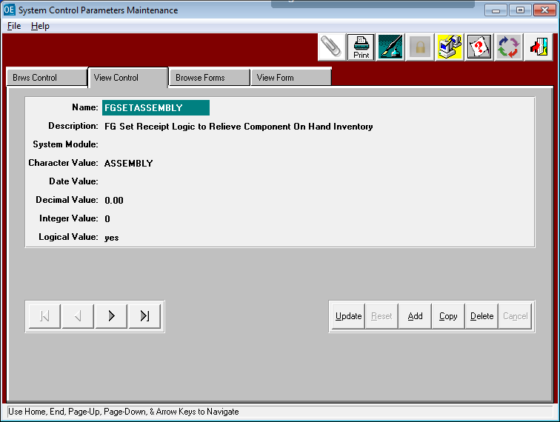

This parameter provides logic for Assembled Set Receipts processed via the (I-U-1) menu keys when the Finished Goods File (I-F-1) Toggle Box fields called Set Header and Assembled are both checked. The reason for the business logic is for components that are produced at Plant A then transferred to Plant B for Assembly. All Pallet Tags are shipped and stored in various Bin Locations (known as Rack Numbers) in Plant B, then specific Pallet Tags will be transferred to the Bin Location called ASSEMBY as a staging location. When adding SET Receipts, the software will be automatically import pallet tags stored in the Assembly bin to the SET PARTS tab of the I-U-1 Set Receipt Screen. When posted they are then subtracted from the components On Hand Inventory and increases the Sets On Hand.

Character Value = ASSEMBLY
A bin location matching the character value must be created in the I-F-4 warehouse file. The bin location defined in the character value will be the default bin for the software to automatically import Set Component Pallet Tags to the SET PARTS tab of the I-U-1 Set Receipt Screen. This will ensure a standard bin location as a staging area for set components to be consumed when adding Receipts for Assembled Sets.

Logical Value = No will use existing Logic that pulls random inventory pallet tags.

Logical Value = YES will turn on this new logic for Adding receipts for assembled sets.
Both O-U-7 Load Tag creation and I-U-1 Set Receipts will receive the Sets Pallet Tags to the warehouse and bin location based on existing logic for N-K-1 FGSetRec parameter which is either a fixed bin or defined by the Sets I-F-1 Warehouse. The sets warehouse will also be default warehouse for the components. However, the components Bin Location will first search on hand Pallet Tags from the Bin Location defined in the N-K-1 FGSetAssembly’s character value such as ASSEMBLY. If there is insufficient component inventory in the Assembly Bin Location, the program will import existing bin Locations. I-U-5 Inventory Posting will not post set receipts or components unless all components have the Assembly Bin locations. The I-U-5 Posting report will show the message, "Component Assembly Bin Location is Required" and they will not Post until Component Bin = Assembly.
SELECT BIN/TAGS Button

The Bottom of the Sets Tab allows selecting specific tags for each component.
As you select component tags, the total selected will appear on the screen.

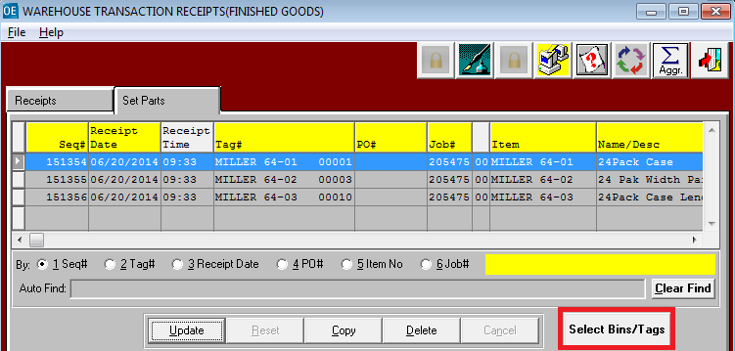

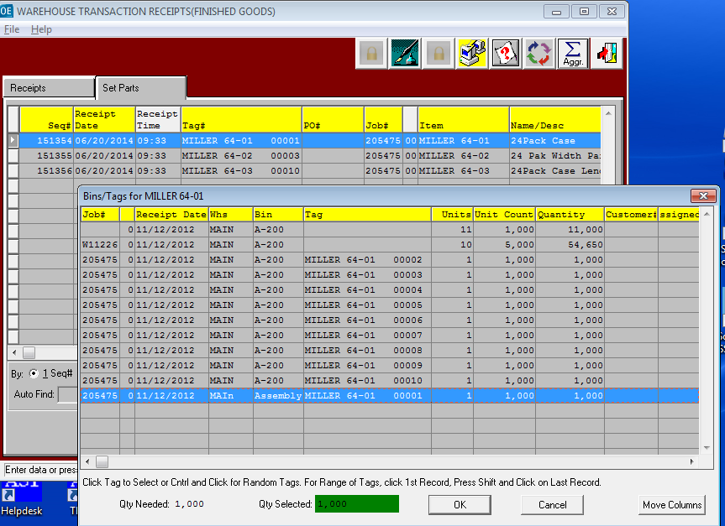
Example of Set Receipt Logic

I have added a set receipt for 1 unit of 1000 assembled sets called Miller 64.
This include 1 RSC, 5 Width Partitions and 3 Length Partitions.
As you can see, the components are automatically pulled from the ASSEMBLY Bin location.

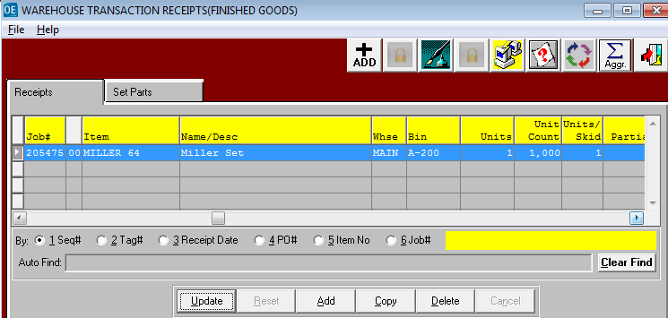

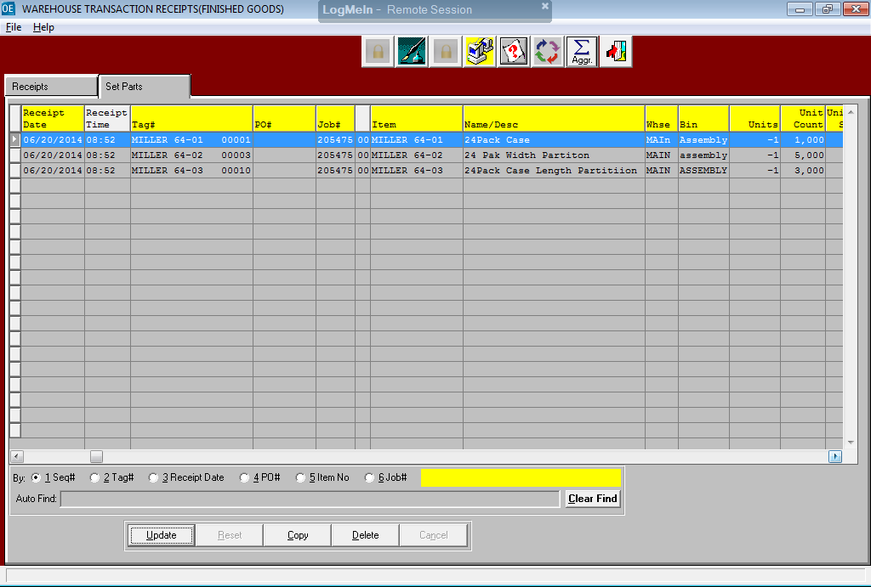
POSTING SETS & COMPONENTS

1 unit of 1000 assembled sets called Miller 64 will be add to On Hand Inventory.
1000 of the RSC 24 Packing Case will be subtracted from inventory.
5000 of the Width Partitions will be subtracted form inventory.
3000 of the Length Partitions will be subtracted form inventory.

